Physiography of India

1. Main Physiographic Divisions:

India can be divided into 5 major physiographical divisions

* The Himalayan Mountains
* The Great Indian Plains
* The peninsular Plateau
* The Coastal Plains
* The Indian Islands

2. The Himalayan Mountains

2.1 Introduction

* Youngest and loftiest mountain chain in the world
* Stretches over 2400Km (22° longitude)
* Width varies from 500km in Kashmir to 200Km in Arunachal Pradesh
* Area covered 5 Lakh Km2
* Pamir knot is the connecting link between Himalayas and the high ranges of central Asia

2.2 Physiographic Divisions of the Himalayas – Divided into 3 parts

2.2.1 The Himalayan Ranges

2.2.1.1 The Shiwaliks

* Outer Himalayas
* Hogback appearance with steep southern slopes
* **Width** varies from 50 Km in Himachal Pradesh to 15 Km in Arunachal Pradesh
* **Altitude** varies from 600-1500 m.
* Gorges of Tista and Raidak have jointly formed a gap of 80-90 Km, in the otherwise unbroken range
* This range at some point obstructed courses of river draining from higher reaches and lakes were created
* These lakes drained out after the rivers carved out a course through the Shiwaliks
* ‘Duns’or ‘Doons’left behind in the West and ‘Duars’in the East.
* The southern slopes of this range in Punjab and Himachal Pradesh, are completely devoid of forests, and are dissected by several seasonal streams called ‘Chos’
* The Shiwaliks are **known by different names** in different regions
  + Jammu Hills in Kashmir
  + Dhang, Dhundwa in Uttarakhand
  + Churiaghat in Nepal
  + Miri, Dafa, Abor, Mishmi in Arunachal Pradesh

2.2.1.2 The Himachals

* Intricate system of ranges 60-80 Km **wide**
* **Altitude** varying from 3500-4500 m.
* Steep, bare southern slopes and gentle forested northern slopes
* Important ranges are
  + Pir Panjal (Kashmir)
  + Dhauladhar (Himachal Pradesh)
  + Moussourie, Nag Tibba (Uttarakhand)
  + Mahabharat, Lekh (Nepal)
* Pir Panjal range extends from the Jhelum river to the upper Beas river (300-400 Km)
* It is separated from the Zanskar range by the **Kashmir valley** (135 Km long 40 Km wide)
* Other notable valleys are Kangra, Kullu (Himachal Pradesh) and Kathmandu valley (Nepal)
* **Best known passes** of the Pir Panjal range are – Pir Panjal pass, Banihal pass, Bidil pass, Golabghar pass
* Middle Himalayas are friendly to human contact, **majority of Himalayan hill resorts** – Shimla, Mussourie, Almora, Ranikhet, Nainital, Darjeeling are located here

2.2.1.3 The Himadris

* Northernmost or innermost of all the Himalayan ranges
* **Average elevation** of 6100 m
* **Average width** of 25 Km
* Abrupt termination or **Syntactical bend** in the Namcha-Barwa in the north east and the Nanga Parbat in the north west
* **Most of the notable peaks** of the Himalayas lie in this range
* **Major passes** of this range are Burzil, Zozila, Bara Lacha, Shipki La, Nathu La, Jelep La, Bomdi La

2.2.2 The Trans Himalayan Ranges

* The Himalayan ranges immediately north of the Himadri are called the Trans Himalayas or Tibetan Himalayas
* **Zaskar**, **Ladakh**, **Karakoram** and **Kailash** are the main ranges of the trans Himalayas
* **Zaskar** range Branches off from the great Himalayas at 80 E longitude, runs parallel to it, terminates at Nanga Parbat (8126 m)
* The **Ladakh** range lies to the north of the Zaskar range
* It is about 300 Km long, average elevation is 5800 m.
* The **Kailash** range in western Tibet is an offshoot of the Ladakh range
* Mt. Kailash (6714 m) is the highest peak of Kailash range
* Northernmost range of the Trans Himalayas is the **Karakoram** range or Krishnagiri range
* K2 is the highest peak of the Karakoram range
* **Ladakh plateau** lies to the north west of the Karakoram range, elevation about 5000 m.

2.2.3 The Eastern Hills

* Himalayas take a sudden southern turn after crossing the Dihang gorge.
* Extends from Arunachal Pradesh to Mizoram, forms India’s boundary with Myanmar
* **Patkai-Bum** in Arunachal Pradesh
* **Kangto** is the highest peak of Arunachal Pradesh
* Merges into the **Naga hills** of Nagaland
* **Saramati** is the highest peak of Naga hills (3826 m)
* South of Naga hills are the **Manipur hills**.
* **Barali** range separate Naga hills from Manipur hills
* South of Manipur hills are the **Mizo hills** (Lushai hills)
* Highest point is the **Blue Mountain** (2157 m)

2.3 Karewa Deposits

* Intermountain valley fill, (lacustrine deposits) made up of unconsolidated grovel and mud
* Formed during Pleistocene period
* Famous for farming of saffron, nuts etc.
* Kashmir valley is known for its Karewa deposits
* Thickness of Karewas is about 1400 m

2.4 Himalayan Glaciers

|  |  |  |  |
| --- | --- | --- | --- |
| **Name** | **Length (Km)** | **Location** | **Mountain Range** |
| Siachen | 75 | Nubra Valley | Karakoram |
| Fedchenko | 74 | S.W Pamir | Karakoram |
| Hispar | 62 | Tributary of Hunza | Karakoram |
| Biafo | 59 | Brabloh valley | Karakoram |
| Batura | 58 | Hunza | Karakoram |
| Baltoro | 58 | Hunza | Karakoram |
| Chogo Lungma | 50 | Rakaposhi Range | Karakoram |
| Khurdopla | 47 | Shingshal Valley | Karakoram |
| Sonapani | 15 | Chandra Valley | Pir Panjal |
| Bara Shigri | 10-20 | Chandra Valley | Pir Panjal |
| Rakhiot | 15 | Nanga Parbat | Pir Panjal |
| Gangri | 13 | Nun Kun Massif | Pir Panjal |
| Chungpar | 13 | Nanga Parbat | Pir Panjal |
| Gangotri | 30 | Source of Ganges (UK) | Kumaon |
| Milam | 20 | Gori Ganga (UK) | Kumaon |
| Pindari |  | (UK) | Kumaon |
| Yepokangara | 13.5 | Gosaithan | Central Nepal |
| Lidanda | 11 | Mansalu | Central Nepal |
| Chhuling | 11 | Mansalu | Central Nepal |
| Rongbuk | 52 | Tibetan side of Everest | Kanchenjunga |
| Zemu | 25 | Zemu valley (Teesta) | Kanchenjunga |

2.5 Regional Division of the Himalayas

* Proposed by Sydney S. Burrard
* Himalayas divided into 4 parts based on river valleys

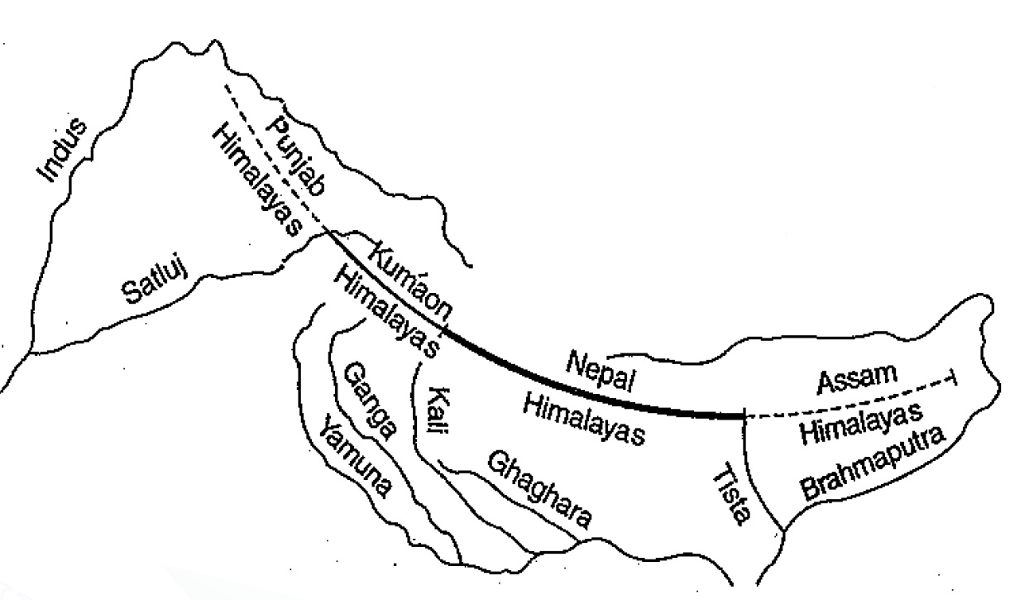

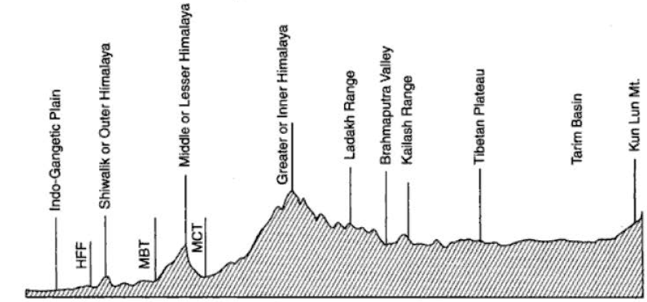2.6 The Himalayan Complex

3. The Great Indian Plains

3.1 Introduction

* Lies to the south of the Himalayas and to the north of the Indian Peninsular region.
* Arcuate (Bow shaped) plain known as Indo-Gangetic-Brahmaputra plains
* Length of 3200 km
* Width varies from 150 km to 300 km.
* Thick layer of alluvium throughout the length and breadth of the plain
* Classic example of aggradational plain.
* According to Oldham, maximum depth of alluvium is 6100 km.
* Average elevation about 200 m.
* Highest elevation of 291 m between Saharanpur and Ambala.

3.2. Geomorphology of the plain

3.2.1. The Bhabar

* Narrow belt about 8-16 km wide running in east-west direction along the foot of the Shiwaliks
* It forms the northern boundary of the great plains
* Rivers descending from the Himalayas deposit their load along the foothills in the form of alluvial fans.
* High porosity of the pebble studded rocks causes the stream to flow underground
* Not suitable for agriculture

3.2.2. The Tarai

* 15-30 km wide marshy tract to the south of the Bhabar region
* It runs parallel to the Bhabar region
* It is marked by the re-emergence of the underground streams of the Bhabar belt
* Re-emerged waters convert large areas along the rivers into ill-drained marshy lands
* Covered with thick forests giving shelter to various wildlife
* The Tarai is more marked in the eastern part as it receives more rainfall
* Most of the tarai specially in Punjab, Uttar Pradesh have been reclaimed and turned into agricultural land
* Yields good crops of sugarcane, rice, wheat.